**Assignments lab 4**

Name: karan Kumar

ID: BIT-23F-002

Section: BSIT 3A

Lab title: 4

Subject:AI

1: Write a Python function to check if a number is even or odd.

* 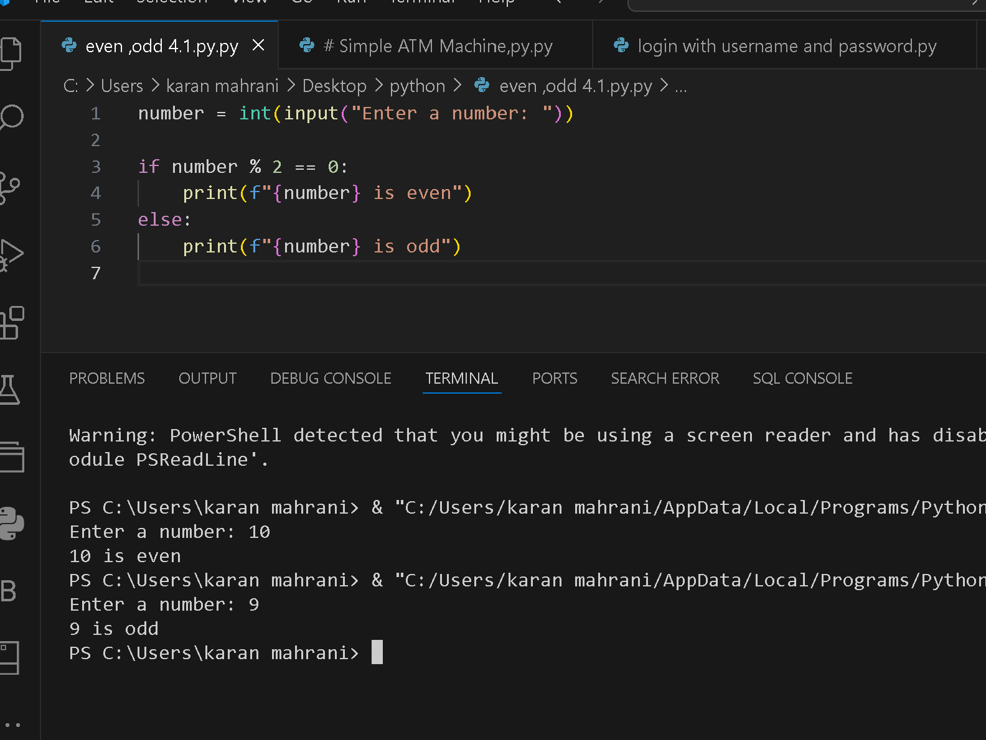

2: Simple ATM Machine Create a simple ATM program where the

user has to enter a PIN to proceed.

● The correct PIN should be 1234.

● If the user enters the correct PIN, display a menu that allows the user

to:

○ Check Balance (display a fixed balance, e.g., 1000).

○ Withdraw Money (ask the user how much they want to

withdraw and deduct that amount from the balance).

● If the user enters an incorrect PIN, print &quot;Incorrect PIN&quot; and terminate

the program.

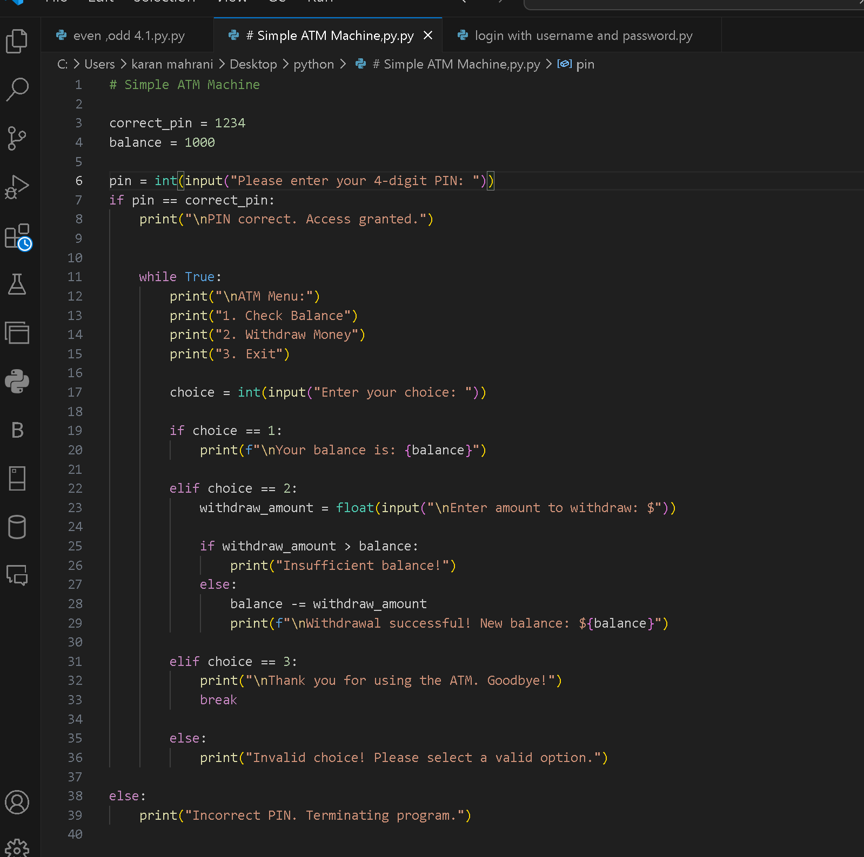

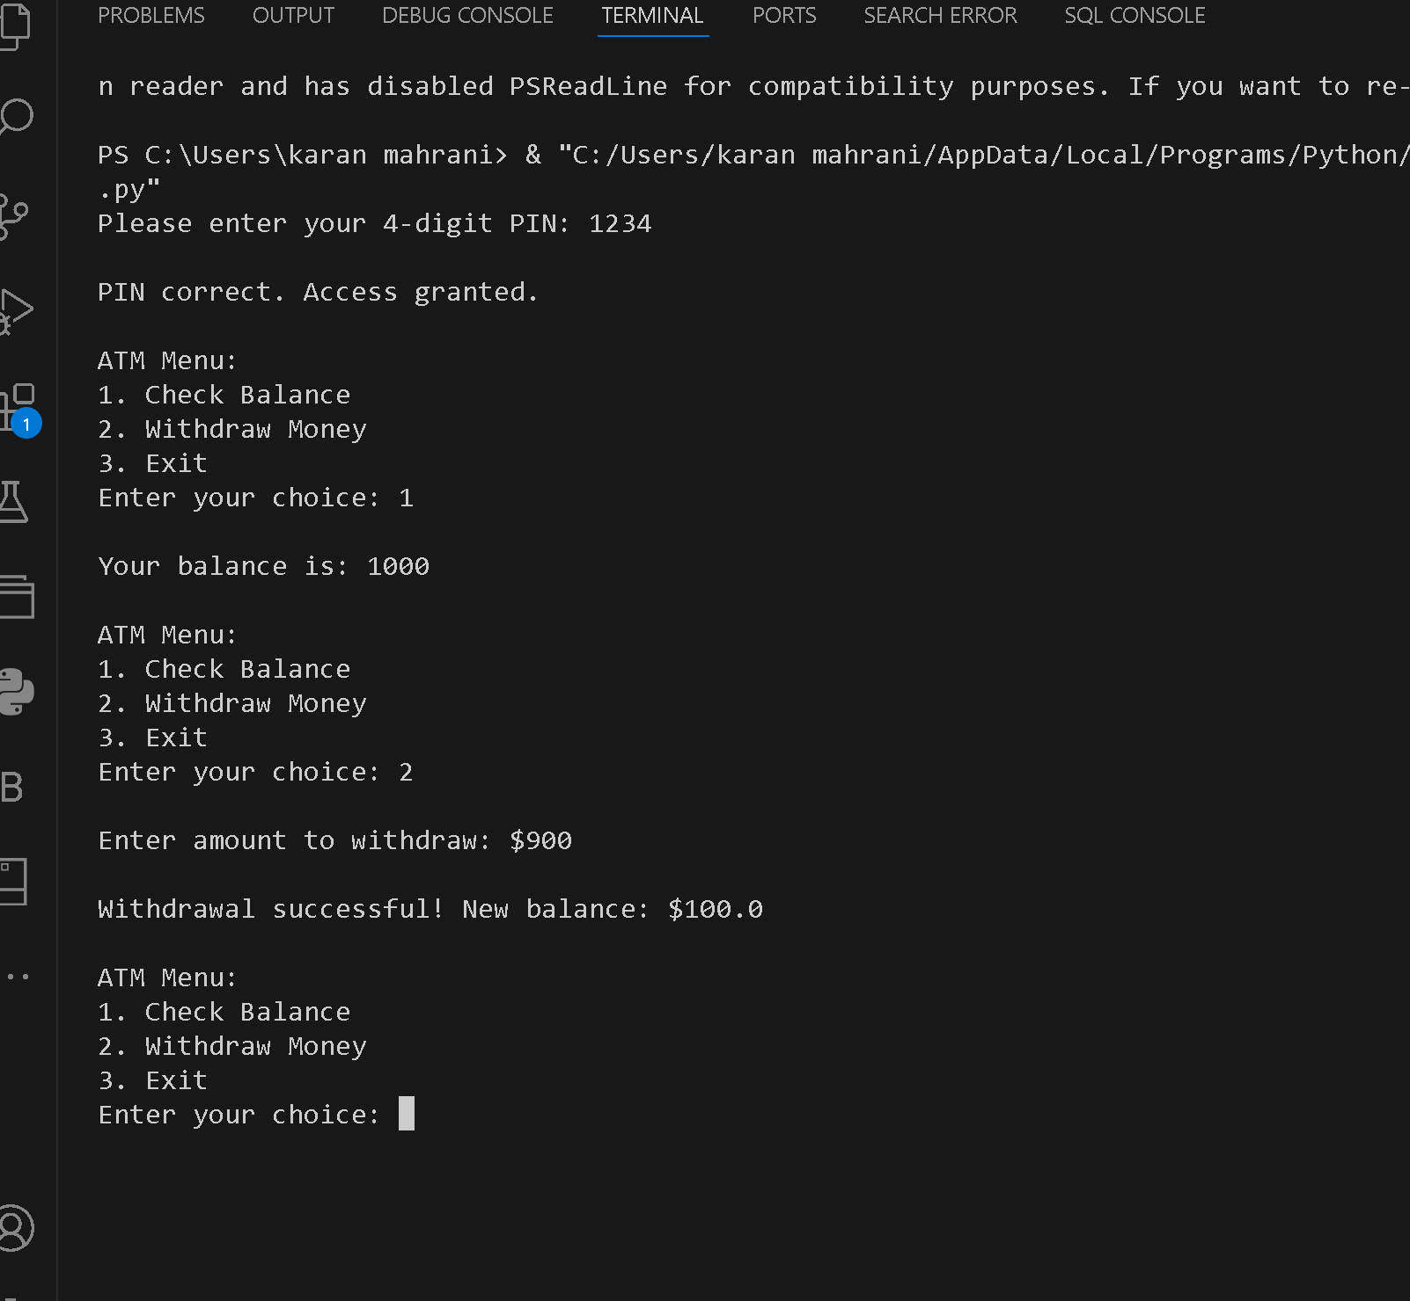

3:Write a program that asks the user to enter a username and

password.

● The correct username should be &quot;admin&quot; and the correct password

should be the numeric value 12345.

● If both the username and password are correct, the program should

display &quot;Login Successful!&quot;.

● If the username is incorrect, display &quot;Incorrect username&quot;.

● If the password is incorrect, display &quot;Incorrect password&quot;.

